LESSON NOTES - 2013
PRIMARY TWO - LITERACY
Week 1, 2, 3 Revision of sounds a, e, i, o, u plus the consonants.
Sound “oo” “u”
School tool look hoot choose
Cook room stool hoof foot
Cool wool good roof loose
Pool root noon doom too
Food boot soon boom zoo
Fool broom book goose cool
Moon spoon soot tooth

- Door has a different sound.
Activity;
1. Listen and write.
2. Spellings
3. Writing sentences
4. Reading the words.

Sound “Wh”
What whose when whenever
Where white wheel whale
Which wheat while whole
Who whom whip why

Sentences.
1. Where do you live?
2. Why are you sad?
3. What are you doing?
4. Who is your father?
5. When do you go to school?
6. Who is your neighbor?
7. When are you coming?
8. I was reading a book while Musa was playing football.
9. This is the man whose bicycle was stolen.

How our school looks like
My name is _________________________________________ I go to learn at _________________________. It is found along _________________________ Road in _____________________ division. Our school is in __________________ district. There is a big sign post infront of the school gate. There are many buildings in our school. Our school is painted ________________________ and ________________________.

Questions
1. What is the name of your school?
2. What is found infront of our school gate?
3. In which division is our school?
4. What is the title of the story?
5. Write any two colours found on your school buildings.
6. Draw our school.

Sound “OU”
Ought fought our hour
Bought found boundary country
Brought drought mouth count
Sour mountain round pound
Ground
Activity
1. Reading
2. Spelling
3. Dictation
4. Jumbled letters
5. Making sentences using the learnt sounds.

Sentences
1. Dad bought for me a new dress.
2. He fought hard for his dear life.
3. I can count one up to one hundred.
4. He went out an hour ago.
5. The milk is sour.

Sound “CH”
Chalk chin cheap chair
Church chip change chain
Children chick chart cheese
Choose bunch chocolate chase
Search hatch chicken kitchen
Hutch watch catch fetch
Lunch match bench beach
Touch torch

Sentences
1. A bench is made out of wood.
2. Can you carry that bunch of banana?
3. The teacher is sitting on a chair.
4. Christians go to church for prayers.
5. Children fetch water from the well.

Activities
1. Reading
2. Spelling
3. Dictation
4. Drawing
5. Forming sentences

Spelling and dictation
Policeman butcher carpenter
Barber tailor pilot
Cobbler teacher fisherman
Doctor shopkeeper mechanic
Activity
1. Filling in missing letters.
2. Jumbled words.
3. Drawing.
4. Matching

Conversation (From Nile English course Book 5)
Bitten by a snake
Jane: Have you heard the news Sarah?
Sarah: What news?
Jane: Our friend John was bitten by a snake
Sarah: Oh! Is he going to be alright?
Jane:

Questions
1. How many people are talking?
2. Who was bitten by a snake?
3. Write the opposite of enemy.
4. What is the title of the story?
5. Draw a snake.

Sound “ght”
Light caught bright bought
Right height slight brought
Fight sight plight drought
Might flight ought night
Weight

Sentences.
(a) We should avoid fighting.
(b) The policeman caught a thief.
(c) Most children are bright.
(d) The teacher has brought a chart.
(e) Mother bought a new car.

Activities;
1. Reading
2. Dictation
3. Making sentences.
Sound “e, a”
Pea eat leaves learn ear
Steal leaf beat lean hear
Flea earn bleat clear rear
Ream smear hear fear fear
Gear pear leak
Sentences
1. A sheep bleats.
2. We eat food.
3. He is leaning against the wall.
4. She brought a ream of paper.
5. Leaves make food for the plant.
Activity;
1. Reading
2. Dictation
3. Jumbled sentences
4. Spellings.

Spelling and dictation.
Policeman fight food material
Gun children medicine quarrels
Uniform teacher water thief
Army labour friends
Land security money
Furniture education trespassing
Activities
1. Dictation
2. Reading
3. Spellings
4. Making sentences

Opio’s bad day
One day, when Opio was going to school, he met a mad man. The madman threw stones at Opio. He ran as fast as he could up to school.

When he entered his classroom, he did not find a chair to sit on because thieves had stolen all the chairs in the school.

At breaktime, Opio missed porridge and went to play football. While playing, a big boy came and started to beat him. He also fought back.
Activity:
1. What is the name of the boy in the story?
2. What did Opio meet on the way to school?
3. Who stole chairs in Opio’s school?
4. Did Opio eat porridge at break time?
5. Write down the title of the story.
6. Draw a madman throwing stones at Opio.

Picture Composition

1. Whose is feeding the chicken?
2. How many people do you see in the picture?
3. What is Nagudi doing?
4. Write down two plants you can see in the picture
(a) ____________________________________ (b) _______________________________________
5. What is the dog eating?

Sound “gr”
Grade grass grate angry
Ground grain grant grip
Grace greet grunt grow
Green grey hungry grew
Great grandmother grandfather
Activities
1. Reading
2. Spelling
3. Dictation
4. Making sentences using the words.
5. Drawing pictures e.g.
6. grandmother
7. Grand father
8. grass
Sound “th”
Both  Thin  Thigh  Throw  Mouth  South  Fifth  Teeth  thread | Bath  Thron  Thick  Thing  Threat  North  Earth  thief | That  There  Than  Those  This  With  Weather  bother | Other  Mother  Father  Brother  Bathe  These  then

Activities
1. Spelling
2. Dictation
3. Filling in missing letters.
4. Making sentences.

Spelling and dictation
Father son cousin
Mother daughter aunt
Grandmother niece grand parents
Uncle nephew family
Activity
1. Reading words
2. Drawing family members
3. Making sentences
Comprehension
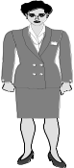
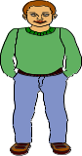
Family tree

Mrs. Kizito Mr. Kizito Mrs. Male Mr. Male

Grandmother Grandfather

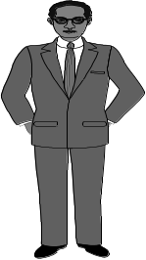
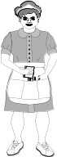
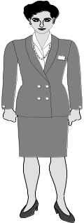
Aunt Sarah Mr. Lule
Father Mother
Uncle Tom Mrs. Lule
Uncle Peter Aunt Mary

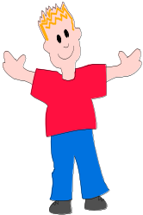
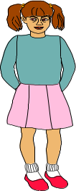
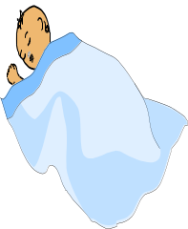

John Joy Jane
Children
Questions
1. Who is John’s father?
2. Who is John’s aunt?
3. What is the name of John’s sister?
4. Whose father is Mr. Kizito?
5. What do you call the sister of your mother?
6. Draw your family members.

Composition
Fill in the missing words
The ant and the pigeon.
Sitting, saw, hunter, ant, days, friends

An __________________________ and a pigeon were good ________________________. One day it rained and the ant was about to be drowned into water.

The pigeon ____________________________ and helped it by throwing a leaf in the water. The ant climbed the leaf and was saved. After a few days, the pigeon was sick so it was ____________________________ on a tree. One hunter came to shoot him with the __________________________. But the ant saved the pigeon by biting the ___________________ on his foot.

Sound “ck”
Sick ticket duck packet sock
Pick jacket luck rock stock
Lick tick thick rocket lock
Kick bucket sacket cock mock
Chick back sack dock knock

Activities
1. Reading
2. Spelling
3. Dictation
4. Drawing
5. Finding words from the puzzle.

Puzzle
s | i | c | k | a | b | c
t | d | p | i | c | k | f
x | b | u | c | k | e | T
j | a | c | k | e | t | I
a | c | o | c | k | i | C
c | k | y | z | b | c | K
k | t | r | i | c | k | o

Circle words with sound “CK”

Composition
Children will write free composition about their home.

Sound “ee”
Sheep creep meet free geese been knee
Sleep greet teeth green weeding pee kneel
Sweep feet fleet reeds need bees feel
See seed fee weed seen keep wheel

Activities
- Reading
- Spelling
- Dictation
- Making sentences.
Fill in the correct word.
1. We use a knife to _____________________________.
2. We use a broom to ____________________________
3. It is good to ____________________________ our parents.
4. Leaves on a plant are colour ____________________________
5. Tongue is to test as skin is to ______________________
6. We brush our _______________________ to avoid bad smell.
7. The plural of goose is ___________________________
8. _______________________ give us honey.
9. Un wanted plants in a garden are called _______________________.
10. A young of a __________________________ is called a seedling.

Sound “pr”
Pray priest apron prove pretend
Preach prince approach proof properly
Present pride press project protect
President proud plural pressure protector.

Activities
- Reading
- Spelling
- Dictation
- Making sentences.

1. We go to church for prayers.
2. A president heads a country.
3. All the children are present.
4. A priest leads prayers.
5. Houses protect us from rain and sunshine.
6. Do not pretend to be sick.
7. We have a prince in our village.

Jumbled story about our home in different cultures.
Re-arrange these sentences to make a sensible story.
1. Next I wear my night dress.
2. Before going to bed, I first brush my teeth.
3. I then say a prayer with my parents.
4. After the prayer, I say, “Good night” to my parents.
5. Then I wash my face and feet.

1. _____________________________________________________________________________________
2. _____________________________________________________________________________________
3. _____________________________________________________________________________________
4. _____________________________________________________________________________________
5. _____________________________________________________________________________________

Sound “ew”
Few view dew grew chew drew new threw knew flew

Read the sentences.
1. The bird flew a few metres away.
2. The boy yesterday drew a very good picture.
3. Look at the view of our school.
4. Allen threw a stone to a mad dog yesterday.
5. I never knew the answer when the teacher asked.
6. We have few chairs in our classroom.
7. Next Christmas, I will get a new dress.
8. She is chewing from class.

Sound “ne’
Nest next neck net necessary nectar never

Activities
- Reading
- Spelling
- Dictation
- Making sentences.

Walk taste touch hear skin nose
I am a boy. God gave me eyes to see, two legs to ___________________________ and the _________________ to smell. I have two ears to ___________________________. I use the fingers to _____________________ things and the __________________________ to feel. God gave me the tongue. I use it to ________________________ my food. Oh! God is so good.

Spellings and dictations
Mouth ears nose thigh chest stomach eyes fingers leg chin knee neck hands toes lips.
Activity;
- Reading
- Spelling
- Making sentences
- Dictation

Fill in composition (Picture)
Star, wonder, above, sky, little

Twinkle Twinkle _________________ star.
How I _____________________ what you are.
Up _______________________ the world so high.
Like a diamond in the _________________________.
Twinkle little ___________________________________

Sound “oa”
Soap coal boat charcoal goat foal coat loaf
Activities:
Sam: Where are going my little goat?
Goat: I’m going to market to buy a new coat.
Sam: A coat for a goat! Can a goat have a coat?
Goat: People will laugh at a goat with a coat.
Questions
1. Which animal is in the story?
2. Where was the goat going?
3. Write the opposite of old, cry.
4. Draw a goat.

Sound “oi”
Boil soil foil voice coil spoil join choice oil toil noise.
Activities
1. Finding the odd man out.
Boil, fork, soil, coil
2. now, noise, spoil, choice,
3. spear, fear, dear, join.

5. Reading
Dictation.

Spelling and dictation
Throw, rubbish, sweep, scrub, pick, soap, boil, slash, wash, dustbin, dump, water
Activities;
- Reading
- Spelling
- Dictation
- Making sentences

Guided composition
Magara lives in a small __________ near the river. He goes to dig with a __________

and a _______________. He plants in his garden. Magara carries the beans in a big

______________.

Sound “sw”
sweep sweet swear swindle swiss swift
Swallow swing swam switch swamp swarm
Swim sweat swept swum swine swish
Swollen swell swear sweater swan swab
Activities
- Reading
- Spellings
- Dictation
- Making sentences
Arranging words to make correct sentences.
- Sweet is honey.
- Honey is sweet.
- Sweeping the I am house.

Free composition (Personal hygiene)
Children write their own composition.

Sound “str”
Strong ostrich stress struck
String stroke straight strap
Straw street strand structure
Stream strip astray strike

Activities
- Reading
- Spellings
- Dictation
- Making jumbled words
- Making sentences
“Sound “pl”
Play plan plumber please pluck plus plate
Splash plait plot place plough plug platform
Plant plaster plead pledge plural player plain
Plague plastic apple simple apply

Activities
- Reading
- Spelling
- Dictation
- Making sentences
Spelling and dictation
Cassava, maize bananas sweet potatoes groundnuts fish apples matooke eggs cucumber, beans peas chicken ovacado carrots cabbage onions tomatoes macrons carrots

Activities
- Reading
- Spelling
- Dictation
- Drawing
- Making sentences

Passage about food
Food is something that we eat or drink. We can get food from the market, gardens, farms or shops. Some food like fish is got from water. Some insects and some animals are also eaten as food.

People eat energy giving foods like cassava, sweet potatoes and rice to get energy.
Body building foods like fish, rice and beans are eaten to help people grow well.

Fruits and vegetables are healthy giving foods. They protect us from diseases. A meal with all this food is called a balanced diet.
Questions:
1. What is food?
2. Write down any four places where food is got.
3. Match
Eggs healthy giving foods.
Potatoes energy giving food.
Pineapple body building food.

4. Draw a balanced diet in a basket.

TERM II.
1. SOUND ‘ng’
Wing king bang
Sing ring hung
Sting bring rung

Sentences
1. That bird has a wing.
2. Can you sing for me.
3. Bees sting.
4. I have a new ring.
5. He is the king.
6. Bring us some juice

Letter pattern
KK KK KK KK KK KK KK KK KK KK KK KK KK KK
KK KK KK KK KK KK KK KK KK KK KK KK KK KK

Dictation
2. Spelling and dictation
Spell words correctly.
A c l me __________________________ n m oeky ______________________
l m I k __________________________ nski ______________________
hespe _________________________ nsake ______________________
mdoetsc __________________________ pehleant ______________________
onil _________________________

Dictation
(pupils listen to teacher and write)

Activity:
1. Use the above work.
2. Fill in the missing letters.
H o __ e d __ m e s __ I c l e o p a r __ w __ __ l m __ a t
S n __ k e etc
3. Read the story and answer questions in full sentences.
Domestic animals
Domestic animals are animals kept in our homes. These include; cows, goats, cats, dogs, rabbits, sheep, horses, donkeys, camels and oxen. These animals have different uses to us. From some of these animals we can get skins, meat, milk, wool, fur; others help us with transport, guarding our homes, killing rats and snakes from our homes and some help us in our gardens.

Questions
1. What are domestic animals?
2. Name any five domestic animals in the story?
3. What do we get from these animals? (Write four uses)
4. Mention the animals that help us with transport.
5. Which animal kills rats and snakes from our homes?
6. We get _____________________ and ________________ from the sheep.

4. Fill in the missing words to make a good story.
Lunch, trip, lions, donkey, snakes, wild bananas.
Last week, P.2 class went for a __________________________ in the wildlife centre. They saw there some ______________ source of the animals were monkeys, _______________, ______________ and leopards. When some children were giving ____________________ to the monkeys, others were riding a ____________________

Later they were served ____________________ from the gardens and lastly they went to Didi’s world.

5. Sound “le”
Words
Bible cattle circle
Title candle needle
Single enable table

Sentences.
1. A herd of cattle.
2. Light that candle.
3. Peace is a single mother
4. A circle has a round shape.
5. The tea is in the kettle.

Activity.
Dictation
1. Fill the missing letters.
C I __ c le t __ b l ___ b I ___ l e c a __ t l e

Spelling and dictation
6. Fill in the missing letters.
S ___ e m f __ u I t g u __ v e r
Lea __ e s ___ l o __ e r g r a p __ s
A __ __ l e p __ w __ a w ___ o o t

Write correctly
M t e s ___________________ f u r i t ________________
P l p a e ___________________ o t r o ________________
L o f e w r _________________ e t c ________________

Dictation
Sound: “oo”
Wool book cool
Root cook pool
Moon room fool

Sentences
1. I have a book in my bag.
2. Can you cook food?
3. I will swim in a pool.
4. Did you see the moon.
5. Plants have roots.

7. Riddles.
1. I have a face but no eyes.
I have no legs but I can walk.
I have two hands but cannot hold anything. What am I? _____________________

2. I am big and small; round and square.
I stand on a shelf or remain on a wall.
You can see yourself in me
What am I? __________________________

3. I have teeth but I don’t bite.
I am black, brown, long or short.
I work hard for you.
What am I? _________________________

4. I am bright.
You see me at night.
I am cool and you like me.
What am I? __________________________

5. We are round, small and big.
We have heads and tails but are not animals.
You are very fond of us.
What are we? __________________________

(Mirror, moon, coins, clock, comb)

8. Use these words to complete the story below;
Kamunya, living, food, banana plants, medicine, building

Plants are __________________ things. They have many uses to people. Some plants are used for __________________. Some are used as medicine and we can get _____________________ materials from plants.

These are some of the plants from which we get ___________________; bean plant, mango plant, ____________ plant, potato plant and many more. Then from these we can get __________________; sere plant, kigaji plant and many others.

9. Underline the odd man out.
1. bread, cakes, buns, biscuits, crisps
2. shirt, coat, dress, trousers, shorts
3. cocoa, bread, tea, coffee, milk
4. teacher, mother, brother, sister, father
5. bungalow, school, house, flat, cottage
6. lady, woman, girl, aunt, boy
7. John, Paul, Muli, Jill, Isaac
8. Cupboard, cup, chair, stool, bed
9. kitten, puppy, cub, goat, chick
10. triangle, oval, line, square, circle
11. star, green, blue, red, yellow
12. plate, bowl, cup, spoon, glass
13. goat, sheep, lion, cow, horse

10. Spelling and dictation
Oral spelling
Mosquito insect fish
Zebra harmful buffalo
Giraffe lamb elephant
Dog horse snake
Dictation: (as teacher desires)

Spellings;
He __ __ og d __ n k e ____
___ h e ep l I __ n h o __ s e
G I r a f __ e ___ o a t

Pattern
Ee Ee Ee Ee Ee Ee Ee Ee Ee Ee Ee Ee Ee
Ee Ee Ee Ee Ee Ee Ee Ee Ee Ee Ee Ee Ee

11. Read and answer the questions
Break Time
At school, we go out for break at 10:30a.m. The bell is sounded and all pupils go out of the classrooms.
Peter and Tom go for porridge with the rest of P.2 pupils. Some pupils bring some eats in their bags and others come with money. Those with money buy eats from the school canteen.

After eating porridge, Primary one pupils together with Primary Two pupils go to the play ground and play. They play all sorts of games they like. Some pupils play on the slides, climbers and some run around the compound.
Questions
1. When do pupils in the story go for break?
2. From the classrooms Peter and Tom go for __________________________
3. Who else goes for porridge?
4. After porridge, where do most pupils go?
5. What do other pupils do?
6. What two things do pupils come with in their bags

12. Make sentences from the table;
Environment  Dry seeds  A seedling  Tom and Sam  Some plants  Plants and animals | are  is | Kept in granary.  A young plant  Things around us  Food sources  Living things  Watering the plants

A ____________________________________________________________________________________________
B ___________________________________________________________________________________________
C ____________________________________________________________________________________________
D ____________________________________________________________________________________________

13. Sound “St”
Stone stair stalk steam
Stop stain stable still
Step steady staff steal
Stick story stage stand
Stood stamp star start

Sentences
1. I have a stick on my table.
2. Come and tell us a story.
3. Put a stamp on your letter.
4. We saw many stars in the sky.
5. Start reading please.
6. I am still writing
7. Stand near your friend.
8. Stop running in the compound.
9. Horses stay in stables.
10. Don’t throw stones.
Ww Ww Ww Ww Ww Ww Ww Ww Ww Ww Ww Ww Ww
Ww Ww Ww Ww Ww Ww Ww Ww Ww Ww Ww Ww Ww

14. Spelling and Dictation on plants.
Stem sere
Roots bananas
Flower yams
Seedling palm leaves
Tobacco coffee
Leaves sorghum
Nalongo sunflower
Mutuba tree
Activity;
- Dictation
- Spelling

15. Read the story and answer questions
Mrs. Budongo’s Craft Shop
Ond Sunday morning, Sarah and her mother went to the shops. They went shopping for many items. They came to a craft shop. This is Mrs. Budongo’s shop” said Sarah’s mother.
In mrs. Budongo’s shop , Sarah saw many crafts. Crafts are things we make with our hands from local materials.

There were baskets, dolls, toy cars, ladles, bangles, necklaces and many more. Sarah picked a nice doll and her mother paid for it.

Questions
1. When did Sarah and her mother go for shopping?
2. Who went with mother to the shops?
3. Name the shop where they went.
4. What are crafts?
5. Mention any two crafts Sarah saw in the craft shop.
6. What craft did Sarah pick out of the many?

Jumbled story
16. Arrange these to make a story.
1. Then he picks the weeds.
2. Lastly he sells the crops.
3. The farmer ploughs the land.
4. He harvests the crops.
5. He plants the seeds.
1. _______________________________________________________
2. _______________________________________________________
3. ______________________________________________________
4. _______________________________________________________
5. ________________________________________________________

Sound “ai”
Pain cain fail
Stain main hail
Said chain tail
Chair pail drain
Laid paid rain
nail sail snail
paint jail rail
hail saint

Sentences
1. Cain is sitting on the chair.
2. I am painting a chair.
3. Peter has a small chain.
4. It is raining now.
Etc
Activity.
1. A _______________________________ cooks food at home. (Cain, maid)
2. _______________________________ are made out of wood. (nails, chairs)
3. Monkeys have long ____________________________ (tail, nail)
4. The boat is ____________________________ on the lake. (Working, sailing)
5. The _____________________________ road is always busy. (main, rail)

18. Jumbled sentences
Chair dog The under is the.
____________________________________________________________________________________________
Is parrot A cage in
____________________________________________________________________________________________
Animals The came useful a
___________________________________________________________________________________________
Dog chasing is the He.
__________________________________________________________________________________________
Brother I two sisters a and have
___________________________________________________________________________________________
Rock standing on is sheena
___________________________________________________________________________________________
Clouds Rain comes the from
___________________________________________________________________________________________
Field the are on playing children The.
____________________________________________________________________________________________
Play well table tennis can I.
___________________________________________________________________________________________
Should We our respect parents.
___________________________________________________________________________________________

19. Rhyme
Read the rhyme below and answer the questions in full sentences.
Ding, Dong, Bell
Ding, Dong, Bell,
Pussy’s in the well.
Who put her in?
Little Johnny Thin
Who pulled her out?
Little Tonny.
Who pulled her out?
Little Tony stout.
What a naughty boy was that,
To drown poor pussy cat,
Who ne’er did any harm,
But killed all the mice
In the farmer’s barn.
Pussy’s = Pussy is ne’er = never.

Questions
1. What animal is in the well?
2. Is it wet or dry?
3. Who put Pussy in the well?
4. What did Tonny stout do?
5. Who was the naughty boy?
6. What did Pussy do?
7. Did the mice like the cat?
8. Where the boys big or small?
9. What do you think Ding Dong is?
10. Tell this story in your own words.

Fill in words correctly to complete the story.
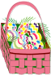
20. Things we make.
At home grandmother makes ______________________ from banana stalks. She also makes _____________________ from palm leaves.
One day she made a __________________ from sisal and said she will make one from
_____________________ leaves. Aunt said people make ______________________ from clay soil and ____________________ ____________________ from wood.

21. Sound “tr”
Train try trunk trapped
Trap tremble trip tree
True trail trum
Triple travel transport
Trust trumpet trainer

Sentences
1. An elephant uses its trunk to drink water.
2. Some animals are used for transport.
3. I saw our scouts’ trainer.
4. He knows the true story.
5. I trapped the rats.
6. We shall travel to Nairobi.
7. She trembles whenever it rains.
8. I can trust my mother.
9. Try to come early.

Pattern;
Pp Pp Pp Pp Pp Pp Pp Pp Pp Pp Pp Pp Pp
Pp Pp Pp Pp Pp Pp Pp Pp Pp Pp Pp Pp Pp

22. Tongue twisters
1. Simple Simon met a piema going to the fair. Said simple Simon to the pieman
Let me taste your fair.

2. Seven silly sisters
Sat sadly on seven silk sacks
At the sea shore.

3. Sally sells sea shells
At the seashore

4. Betty bought a bit of butter
But the bit of butter Betty
Bought was bitter, Betty
Bought another bit of butter
To make the bitter butter
Better.

5. God made man
Man made money
Money made man mad.

23. Read the story and answer questions.
A busy town.
Our town is called Jinja. There people do a lot of jobs and work. Some people sell different items in shops, market. Some sell animals, some drive and others carry luggage. There those who sell raw food and others cooked food.
In the taxi park, you hear people shout calling different stages. Some men unload and load goods from lorries. Some women sell brooms others tea in big kettles.

Questions
1. What is the name of the town?
2. Write any three jobs in the story.
3. What do you hear in the taxi park?
4. What do men do with goods?
5. Some women sell ______________________ and ___________________
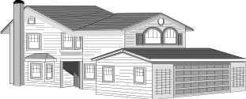
24. Study the picture and write.
Our Transport

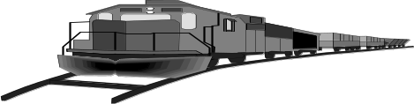

To Mombasa

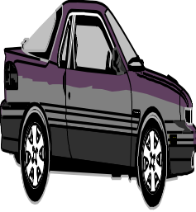
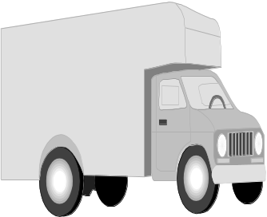
To Gulu

To Kampala

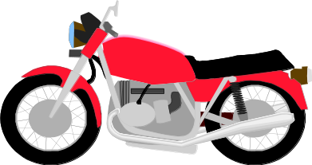

1. How many cars are in the picture?
2. How many lorries can you see in the picture?
3. Name the means of transport in the picture.
4. Where are they coming from?
5. How many motorcycles are in the pictures?
6. Where is the bus going?
7. Name the type of transport in the picture.
25. Sound “sp”
Spot spoon spur
Speak spend special
Spoil spill
Spell sport
Sponge spanner

Sentences;
1. Tonny spell the word spoon.
2. She spent two days in the village.
3. I have two spoons.
4. Do not spoil that food.
5. We use a sponge to bath.
6. At school we do games and sports.
7. Who used daddy’s spanner.
8. We should speak English at school.
9. Our teacher is special to us.
10. Our mother spotted the thief.

Mm Mm Mm Mm Mm Mm Mm Mm Mm Mm Mm Mm Mm
Mm Mm Mm Mm Mm Mm Mm Mm Mm Mm Mm Mm Mm
26. Spelling and dictation
Learn to spell these words.
Train transport driver sailor
Traffic pedestrian pilot conductor
Policeman yellow boat parachute
Aeroplane zebracrossing humps

Dictation: (Pupils write as teacher dictates)
Spelling exercise;
Write correctly;
1. evdri ___________________ btoa ______________________ tainr ____________________
Fitarfc __________________ lopit _____________________ etc
27. Jumbled sentences
1. Cooking mother food is My.
____________________________________________________________________________________________
2. snake beating Peter is.
____________________________________________________________________________________________
3. to children The are running school.
____________________________________________________________________________________________
4. playing She with is ball a.
___________________________________________________________________________________________
5. book is a This nice.
___________________________________________________________________________________________
6. rat The under is chair the.
___________________________________________________________________________________________
7. I three buy will balloons.
__________________________________________________________________________________________
8. drives a He lorry big.
___________________________________________________________________________________________
9. kind is My very aunt
____________________________________________________________________________________________
10. read I now can.
____________________________________________________________________________________________
11. saw king Sarah the.
____________________________________________________________________________________________
12. eat cows grass.
____________________________________________________________________________________________
28. Study the picture and write.

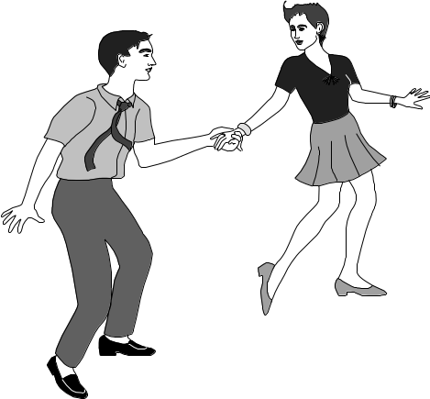

1. What do you do at the traffic lights?
2. What coloured lights are seen at this traffic lights?
3. Which light prepares you to go?
4. Which light tells you to stop?
5. Which light allows you to move?
6. Who are the people crossing the road?
7. What is the mother pushing?
29. Sound “fl”
Fla fle fli flo flue
Flat flag flut flour
Fly flea flock flexible
Flew flow float flight
Flew flow floor flash
Flower flask flop flavor
Flesh flame flamingo
Sentences.
1. The fly is on the flower.
2. Our flag is floating on the water.
3. There are some fleas on the bed.
4. We have a flat house.
5. The bird flew away.
Etc
Activity;
- Reading
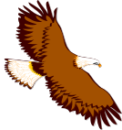
- Forming sentences
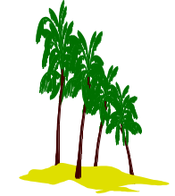
30. Look and write
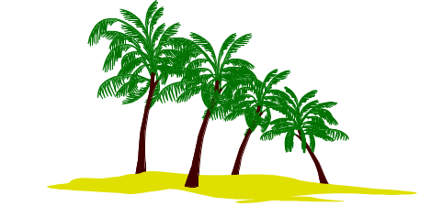

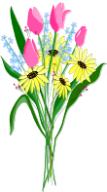


1. What are the children doing?
2. What kind of weather is it?
3. Are these huts or bungalows?
4. How many birds can you see?
5. What else can you see in the picture?
6. What are the birds doing?

TERM III

1. Sound br
Bra bre bri bro bru
Bring bread brag
Brand break Britain
Bricks bridge Britain
Brisk breed breathe
Broth brain brown
Brush breast embrace

Sentences.
1. I like bread with butter.
2. Bridget is a bright girl.
3. Sarah’s breast is paining her.
4. Insects breathe through spiracles.
5. His leg is broken.
6. We are crossing the bridge.
7. We should brush our teeth twice daily.
8. My uniform is brown.
9. Patrick has brought a brand new car home.
10. Bricks are used for building houses.
Activities.
- Reading
- Dictation

Composition.
Fill in the correct word to complete the story.

Kananura and Tusiime go to Nakasero Primary ___________________. They carry
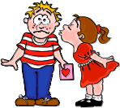
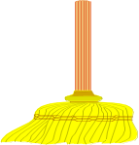
_______________ and ______________ in their bags. After class, Kananura plays with his
_________________. Tusiime stays in class and sweeps it with a ____________________.
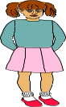
Their ___________________ likes Tusiime very much because she is a hard working girl.

Child Abuse
Child abuse is when a child is denied his or her rights. A child is someone below eighteen years. Some of the causes of child abuse are poverty, alcoholism, broken families, insecurity and others. Children can be abused by beating, burning, laboring, defiling, kidnapping etc. Children should be protected in order to live a happy life.

Questions.
1. What is child abuse?
2. Who is a child?
3. Give two causes of child abuse.
4. List down two types of child abuse
5. What is the title of the story?

Sound ou (read a- u)
Words
Out compound cloud mount found stout
Round bought loud drought mouse louse
Ground bounce house proud mountain
Sentences.
a. Who is outside the house?
b. Was the mouse found?
c. I am proud of my daughter.
d. Nimbus clouds give us rain.
e. A louse is a bad insect.
f. Eron bought groundnuts.
g. Too much sunshine causes drought.
h. I like to bounce the ball.
Activities
1. Dictation
2. Reading
3. Forming own sentences
4. Drawing and naming pictures.

Read the story and answer the questions.
Mr. and Mrs. Muganga have two children. These are Laura and Lenny. Lenny got an accident and one of his leg was cut off. He does not go to school because his parents think that he cant do anything. Lenny is not happy because he is mistreated by his parents. Laura goes to Winston Day and Boarding Primary school everyday. She is happy because she gets all her rights. All children should be given their rights.

Questions
1. How many children do Mr. and Mrs. Muganga have?
2. Who got an accident?
3. Why s Lenny not happy?
4. What happened to Lenny when he got an accident?
5. Why is Laura not happy?
6. Draw Lenny walking with one leg.

Sound ck
Chick flock wick racket
Check pick snack sack
Sock sack knock mock
Tack duck deck bucket
Cock clock pick peck
Lick clock pick peck
Neck rack luck’
Jack
Sentences
1. Jack has a cock.
2. Dick has a black jacket.
3. Pack your bags on the rack.
4. Pick and kick the ball.
5. There is a tick on my neck.
6. I have a lock and a cock.
7. Put the lock in the sack.
8. Bill has a duck and a cock.
9. Kato has a clock and a lock.

Activity
1. Dictation of words and sentences.
2. Fill in missing letters.
3. Reading words and sentences.
4. Arranging the letters to make words.

Teaching sound “kn”
Know known knob
Knee knife knowledge
Knew knives unknown
Knit knock
Knot knicker
Knelt

Read the story and answer the questions
Which one Is The Greatest?
Long time ago, the sun thought it was the greatest and said, I am great, I make people warm and I dry their clothes. The rain said, No I am the greatest, I make plants grow. I give people and animals water.

The clouds said, I am the greatest, I cover the sun, and give people shadow and I help to form rain. The wind shouted, “No, no, no, I am the greatest. They all saw that it was good to work together as a team. They were all important.
Questions.
1. Name the elements of weather mentioned in the story.
2. Write any two uses of the sun.
3. What do clouds do?
4. What makes the plants to grow well?
5. Mention any one use of the water.
6. Write down the title of the story

Composition
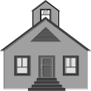
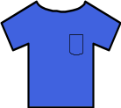
Fill in the correct words to complete the story.

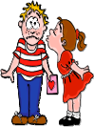
Every Sunday, John and Mary go to ________________. They wear their ______

and _________________. In the church, they sit on the ____________. They are God fearing _____

sound bl
bla ble bli blo blue

blouse blister bliss blast
blue bless blunt bled
blend black blade blessed
blink blind blame blank
able
blanket

Sentences
1. This blanket is blue.
2. This razor blade is blunt.
3. The blind girl has a black blouse.
4. The blessed girl is blinking.
5. My nose is bleeding.
6. Don’t blame me for nothing.
7. God is able
8. Blocks are building materials
Activity
- Reading
- Dictation
- Spelling

Read the story and answer the questions.
Yesterday, Amina and Henry went to town together. They went by bus. Amina saw a pedestrian knocked by a speeding car. After that they went to a supermarket. Henry bought two kilograms of sugar and Amina bought half a kilogram of Nido milk.
Questions
1. Who went to town yesterday?
2. What means of transport did they use?
3. How do we call someone who walks along the road?
4. How many kilograms of sugar did Henry buy?
5. Who bought the heaviest item?
6. Apart from kilograms, give another unit for weight.

Sound ‘ng’
Nga nge ngi ngo ngu
Words
Long slang panga strong
Song tongue bang along
Gang bring ding string
Sing ring fang king
Dung sting wing going
Swing ring rang selling
Hungry lung

Sentences
1. Oundo is clapping her hands.
2. A snake uses fangs to bite.
3. That king has a long tongue
4. Mpanga is a strong boy.
5. Who has rang the bell.
6. Go and bring some water

Activity
1. Dictation of words and sentences.
2. Filling in missing letters.
3. Reading words and sentences.
4. Arranging the letters to make words.

SEASONS
There are two seasons in a year. When there’s a lot of rain it is a wet season and when there is too much sunshine, it is a dry season. The activities done in a wet season are planting and weeding. The activities done in a dry season are ploughing and harvesting.

In a wet season, we plant crops like beans, cabbages, rice and tomatoes. In the dry season, we harvest the crops. Both seasons help us to get enough food.
Questions.
1. How many seasons do we have in a year?
2. What are the activities done in a wet season?
3. Give any two crops that people harvest during the dry season.
4. Why do we need both seasons?
5. What is the story about?
6. Name the elements of weather that make up these seasons;
(a) dry season (b) wet season

Complete the story
Sasha lives in a small ___________________ near the river. He goes to dig with

__________ and _________________. He plants ________________ in

his garden. Michell carries beans home in a big _______________________.

Sound “und”
Unda ude udi undo
Emd blend gland standard
And blind bind ground
Sand blend stand Uganda
Send bland find land
Bend under found land
Attend sound bound mind
Wind understand round behind
Sentences
1. That is the end of the story.
2. The thief was hiding behind the door.
3. Mawanda and Kabanda have a big piece of land.
4. Nakiganda was born in Uganda.
5. Moving air is called wind.
6. Please send me my bag.
7. There’s sand on the ground.
8. Don’t stand under the tree.
9. P.2 North has the highest standard in academic.
10. Can you please find me in the compound?

Activity;
- Dictation of words and sentences.
- Reading
- Fill in missing letters.

CHRISTMAS HOLIDAY
Christmas is the day when Christians celebrate the birth of Jesus Christ. It is celebrated on 25th December every year. Jesus was born to save us from our sins.
Peter and Jennifer went for Christmas holiday at their aunt’s home last year. Their aunt Ritah, was very happy to see them. She made a party for them. They ate a lot of food, drank soda and they also cut a cake. When they were going back home, their aunt gave them some presents.
Questions
1. Where did Peter and Jennifer go for Christmas holiday?
2. Who made a cake for Peter and Jennifer?
3. Why do people celebrate Christmas days?
4. What did their aunt give them when they were going back home?
5. How many people are mentioned in the story?
6. What is the title of the story?
7. When is Christmas celebrated?
8. Why was Jesus born?
9. Draw Peter and Jennifer cutting a cake.

Sound ea say i.
Words
Heal cream clear meal
Peace bean team read
Teacher leave heap peasant
Beak weak bead peas
Sea dream speak teat
Reach east each dear
Beach meat neat ear
Eat leaf spear
Beat
Seat

Activity;
- Reading the word
- Dictation of the words.
- Jumbled letters.
- Drawing and naming.

Fill in the correct words
Meals beads hear dream each easy meat seat read tea
1. We eat three _______________________ in a day.
2. This baby has many _____________________ in her hairs.
3. Last night I had a very funny ________________________.
4. Take a seat and _______________________ for me this book.
5. You will need some hot _______________________ to drink.
6. I want to buy three kilos of ___________________ from the butcher’s.
7. This number is very ________________________________.
Read the story and answer the questions in full sentences.
One day Kakuru was coming to school. He met a thief. The thief grabbed his bag and ran away. He cried and shouted for help. A policeman came and arrested the thief.

Questions.
1. Who was coming to school?
2. Whom did Kakuru meet?
3. Why did Kakuru shout?
4. Who arrested the thief?
5. Why do you think the policeman arrested the thief?
6. Who keeps law and order?
7. How many people are in the story?
8. Is a thief a good man?
9. Draw a thief grabbing Kakuru’s bag.
Arrange these sentences in order to form a good story.
a. He met a thief.
b. A policeman came and arrested the thief.
c. The thief grabbed his bag.
d. One day Kakuru was coming to school.
e. He shouted for help.
a. _______________________________________
b _______________________________________
c. _______________________________________
d. _______________________________________
e. _______________________________________
Sound oa-o
Words
Loaf loan cupboard boast
Coal oak goal roar
Load soap coat
Boat float oats
Sentences
1. Jane has a loaf of bread.
2. The goat is in the boat.
3. Get a piece of soap from the cupboard.
4. I got a loan and bought a coat.
Etc.

Read the story and answer the questions
SIGNS OF MEASLES
One day, John fell sick. His body was too hot and he became weak. His eyes were red and watering. He had headache. He could not eat or drink. The whole day, developed a rash. When he was taken to the hospital, the doctor said John had measles. Measles is a childhood killer disease like polio, tetanus, whooping cough, diphtheria and tuberculosis.
Questions.
1. Who fell sick?
2. What was the colour of John’s eyes?
3. John’s body developed a _________________________
4. Could John drink or eat?
5. What was he suffering from?
6. Mention any three other childhood killer diseases.
7. Who treats sick people?
8. What is the title of the story?
9. Draw a child suffering from measles.

15. Re-arrange these sentences to make a good story.
a. His mother was very happy.
b. He then sold it and got money.
c. Kato went to the swamp.
d. He modeled a very big pot.
e. He got clay.
____________________________________________________________________________________________
____________________________________________________________________________________________
____________________________________________________________________________________________
___________________________________________________________________________________________
___________________________________________________________________________________________

Sound “st”
Story stone stick stable
Stop step stem stamp
Stalk star storm

16. Read the story and answer in full sentences.
Carol is a little girl. She is studying in standard Two. The children are having Christmas holidays. On Christmas everyone gets new clothes. Carol got a pretty pink dress with white dots. She had pink ribbons and white socks to match the dress. On Christmas day, Carol and her parents dressed up to go to Church. Daddy had a new brown suit and mummy had a lovely blue dress. She had a big hat to match the dress. They all looked very smart but Carol looked the best.
Questions.
1. What is the name of the little girl?
2. In which class is Carol?
3. What did Carol get on Christmas?
4. What did she have to match the dress?
5. Where were they going?
6. What did daddy wear?
7. Who looked the best of all?
8. What did mummy wear?
Jumbled Story
17. Arrange the story in correct order.
1. Then we go to our class.
2. We go to school.
3. Our teacher teaches us.
4. Ali rings the bell.
5. We have an assembly and we pray.

18. Study the picture and answer the questions that follow;
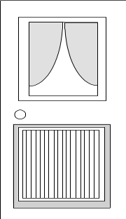
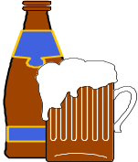
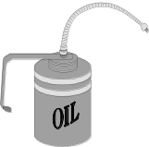
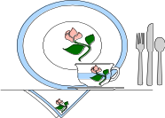

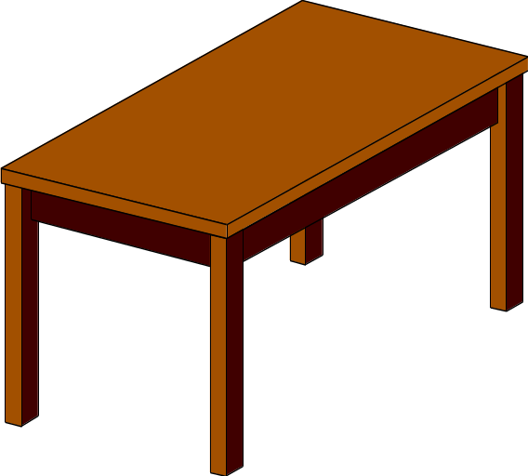
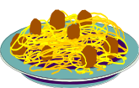
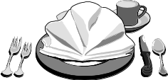

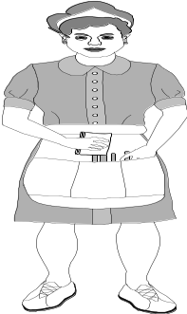
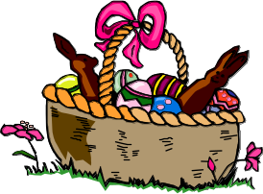

1. How many people can you see in the picture?
2. Who are they?
3. What do you see on the kitchen table?
4. What things are seen on the shelf?
5. How many legs has the round stool?
6. What is the woman holding in her hand?
7. Is it a picture of a dining room?

19. Read the passage and answer the questions.
The largest bird in the world is the ostrich. Most ostriches live in Africa. An ostrich is as tall as a person. It is so strong that a child can sit on its back. It can run as fast as a horse and it can kick as hard as a horse. Its wings are very small and it cannot fly but it uses its wings to help it to keep its balance when it runs fast.

Questions.
1. Which bird is talked about in the story?
2. Where are most ostriches found in the world?
3. What is the story about?
4. Why cant an ostrich fly?
5. What do ostriches use their wings for?

